STUDENT CELLPHONE POLICY & GUIDELINES

Cellphones are not to be used during school. Every student is assigned a personal Yondr Pouch. While the Yondr Pouch is considered school property, it is each student’s responsibility to bring their Pouch with them to school every day and keep it in good working condition.

DAILY PROCESS

As students Arrive to School, they will:
- Turn their cellphone off.
- Place their cellphone inside the Pouch and secure it in front of school staff.
- Store it in their backpack for the day.

At the end of the day, students will open their Pouch, remove their phone, close their Pouch and put it in their backpack. Students must bring their Pouch to school with them each day.

*Students arriving late or leaving early will pouch/unpouch their phones in the Main Office.

VIOLATIONS

Pouch Damage / Lost Pouch / Using Cellphone During School
If a student damages their Pouch or is caught on their phone, Administration will collect the cellphone/Pouch and call home:

- 1st Offense: Phone will be confiscated. The phone will be returned to the student at dismissal.
- 2nd Offense: Phone will be confiscated. Lunch Detention and Parent Meeting. The phone will be returned to a parent/guardian only.

Examples of damage:
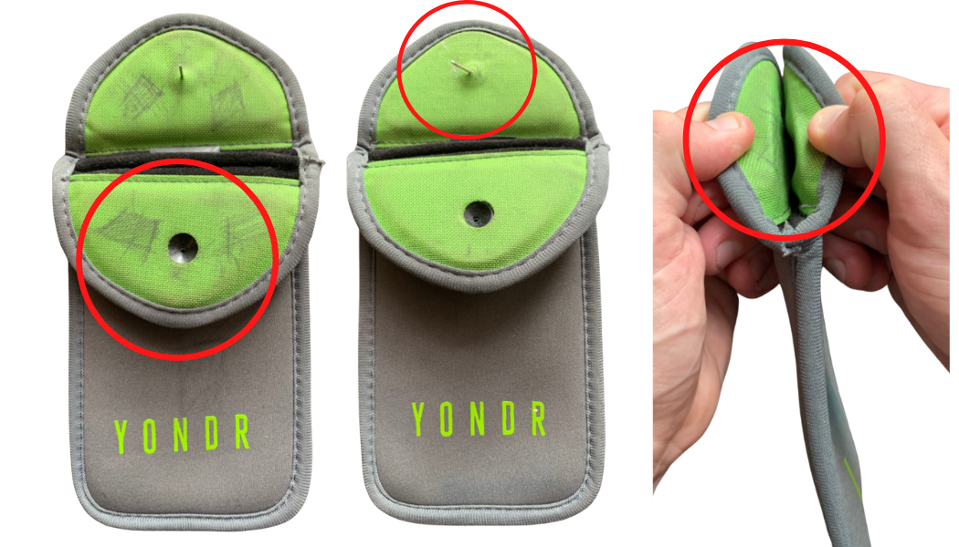 | - Ripped  - Cut  - Torn  - Pen/pencil marks  - Bent/cut pin  - Signs of force to black button on flap

Forgotten Pouch
If a student forgets their Pouch, their cellphone will be collected and Admin will call home to remind the Parent of the policy. The phone will be returned to the student at dismissal.

If a student consistently forgets their Pouch, it is considered Lost.
Refer to the Lost Pouch policy above.

